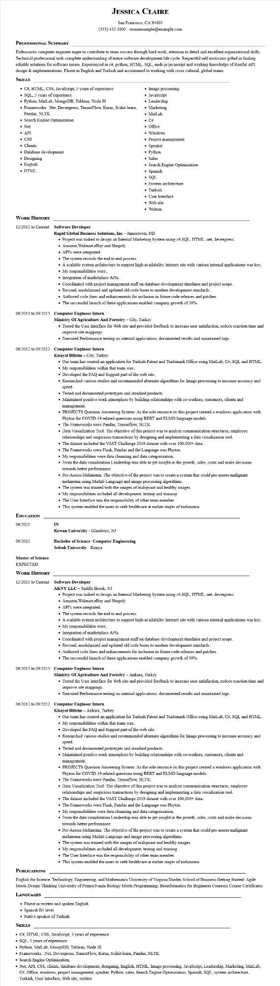
JESSICA CLAIRE
San Francisco, CA 94105
(555) 432-1000 - resumesample@example.com
PROFESSIONAL SUMMARY
Enthusiastic computer engineer eager to contribute to team success through hard work, attention to detail and excellent organizational skills. Technical professional with complete understanding of entire software development life cycle. Respectful self-motivator gifted at finding reliable solutions for software issues. Experienced in c#, python, HTML, SQL, node.js/javascript and working knowledge of Restful API design & implementations. Fluent in English and Turkish and accustomed to working with cross-cultural, global teams.
SKILLS
• C#, HTML, CSS, JavaScript, 5 years of experience
SQL, 5 years of experience
• Python, MatLab, MongoDB, Tableau, Node JS
• Frameworks: .Net, Devexpress, TensorFlow, Keras, Scikit-learn,
Pandas, NLTK.
• Search Engine Optimization
• Net
• API
Image processing
JavaScript
• Leadership
• Marketing
• MatLab
• C#
• Office
• Windows
• Project management
• CSS
• Clients
• Database development
Designing
• English
• HTML
WORK HISTORY
•
Speaker
• Python
• Sales
• Search Engine Optimization
•
Spanish
• SQL
• System architecture
• Turkish
• User Interface
• Web site
• Written
12/2015 to Current Software Developer
Rapid Global Business Solutions, Inc - Jamestown, ND
• Project was tasked to design an Internal Marketing System using c#, SQL, HTML, .net, devexpress.
• Amazon, Walmart, eBay and Shopify.
• API's were integrated.
• The system records the end to end process.
• A scalable system architecture to support high-availability Internet site with various internal applications was key. • My responsibilities were:.
• Integration of marketplace APIs.
• Coordinated with project management staff on database development timelines and project scope.
• Revised, modularized and updated old code bases to modern development standards.
• Authored code fixes and enhancements for inclusion in future code releases and patches.
• The successful launch of these applications enabled company growth of 30%-
06/2013 to 09/2013 Computer Engineer Intern
Ministry of Agriculture And Forestry - City, Turkey
• Tested the User Interface for Web site and provided feedback to increase user satisfaction, reduce reaction time and improve site mappings.
• Executed Performance testing on internal applications, documented results and maintained logs.
06/2012 to 09/2012 Computer Engineer Intern
EDUCATION
06/2021
Kisayol Bilisim - City, Turkey
IN
• Our team has created an application for Turkish Patent and Trademark Office using MatLab, C#, SQL and HTML. My responsibilities within that team was:.
•
• Developed the FAQ and Support part of the web site.
• Researched various studies and recommended alternate algorithms for Image processing to increase accuracy and speed.
• Tested and documented prototypes and standard products.
• Maintained positive work atmosphere by building relationships with co-workers, customers, clients and management.
• PROJECTS Question Answering System: As the sole resource on this project created a windows application with Phyton for COVID-19 related questions using BERT and ELMO language models.
• The Frameworks were Pandas, Tensorflow, NLTK.
• Data Visualization Tool: The objective of this project was to analyze communication structures, employee relationships and suspicious transactions by designing and implementing a data visualization tool.
• The dataset included the VAST Challenge 2019 dataset with over 100,000+ data.
• The Frameworks were Flask, Pandas and the Language was Phyton.
• My responsibilities were data cleansing and data categorization.
• From the data visualization Leadership was able to get insight in the growth, sales, costs and make decisions towards better performance.
• Pre-Assess Melanoma: The objective of the project was to create a system that could pre-assess malignant melanoma using Matlab Language and image processing algorithms.
• The system was trained with the images of malignant and healthy images.
• My responsibilities included all development, testing and training.
• The User Interface was the responsibility of other team member.
• This system enabled the users to seek healthcare at earlier stages of melanoma.
06/2015
Master of Science
EXPECTED
WORK HISTORY
Rowan University - Glassboro, NJ
Bachelor of Science: Computer Engineering
Selcuk University - Konya
12/2015 to Current Software Developer
AKNY LLC - Saddle Brook, NJ
• Project was tasked to design an Internal Marketing System using c#, SQL, HTML,.net, devexpress.
• Amazon, Walmart, eBay and Shopify.
• API's were integrated.
• The system records the end to end process.
• A scalable system architecture to support high-availability Internet site with various internal applications was key.
• My responsibilities were:.
• Integration of marketplace APIs.
• Coordinated with project management staff on database development timelines and project scope.
• Revised, modularized and updated old code bases to modern development standards.
• Authored code fixes and enhancements for inclusion in future code releases and patches.
• The successful launch of these applications enabled company growth of 30%.
06/2013 to 09/2013 Computer Engineer Intern
Ministry Of Agriculture And Forestry - Ankara, Turkey
• Tested the User Interface for Web site and provided feedback to increase user satisfaction, reduce reaction time and improve site mappings.
• Executed Performance testing on internal applications, documented results and maintained logs.
06/2012 to 09/2012 Computer Engineer Intern
Kisayol Bilisim - Ankara, Turkey
• Our team has created an application for Turkish Patent and Trademark Office using MatLab, C#, SQL and HTML.
• My responsibilities within that team was:.
• Developed the FAQ and Support part of the web site.
• Researched various studies and recommended alternate algorithms for Image processing to increase accuracy and speed.
• Tested and documented prototypes and standard products.
• Maintained positive work atmosphere by building relationships with co-workers, customers, clients and management.
• PROJECTS Question Answering System: As the sole resource on this project created a windows application with Phyton for COVID-19 related questions using BERT and ELMO language models.
• The Frameworks were Pandas, Tensorflow, NLTK.
• Data Visualization Tool: The objective of this project was to analyze communication structures, employee relationships and suspicious transactions by designing and implementing a data visualization tool.
• The dataset included the VAST Challenge 2019 dataset with over 100,000+ data.
• The Frameworks were Flask, Pandas and the Language was Phyton.
• My responsibilities were data cleansing and data categorization.
• From the data visualization Leadership was able to get insight in the growth, sales, costs and make decisions towards better performance.
• Pre-Assess Melanoma: The objective of the project was to create a system that could pre-assess malignant
melanoma using Matlab Language and image processing algorithms.
• The system was trained with the images of malignant and healthy images.
• My responsibilities included all development, testing and training.
• The User Interface was the responsibility of other team member.
• This system enabled the users to seek healthcare at earlier stages of melanoma.
PUBLICATIONS
English for Science, Technology, Engineering, and Mathematics University of Virginia Darden School of Business Getting Started: Agile Meets Design Thinking University of Pennsylvania Biology Meets Programming: Bioinformatics for Beginners Coursera Course Certificates
LANGUAGES
• Fluent in written and spoken English
• Spanish B1 level
• Native speaker of Turkish
SKILLS
• C#, HTML, CSS, JavaScript, 5 years of experience
• SQL, 5 years of experience
• Python, MatLab, MongoDB, Tableau, Node JS
• Frameworks: .Net, Devexpress, TensorFlow, Keras, Scikit-learn, Pandas, NLTK.
• Search Engine Optimization,
• Net, API, CSS, clients, database development, designing, English, HTML, Image processing, JavaScript, Leadership, Marketing, MatLab,
C#, Office, windows, project management, speaker, Python, sales, Search Engine Optimization, Spanish, SQL, system architecture, Turkish, User Interface, Web site, written

